**Name: Muhammad Taha**

**Section: B**

**CMS_ID: 023-23-0377**

**Assignment: Lab6**

Task1: package lab6; public class Task1 {

int i,j,min_ind; void Sort(int arr[]) {

int n=arr.length; for(int i=0;i<n-1;i++){ min_ind=i; for(j=i+1;j<n;j++){ if(arr[j]<arr[min_ind]){ min_ind=j; int temp=arr[i]; arr[i]=arr[min_ind]; arr[min_ind]=temp;

}

}

}

}

void printArray(int arr[])

{ int n = arr.length; for (int i=0; i<n; ++i)

System.out.print(arr[i]+" ");

System.out.println();

}

public static void main(String args[]) { Task1 ob = new Task1(); int arr[]={23,45,65,1,45,67}; ob.Sort(arr); ob.printArray(arr);

} }

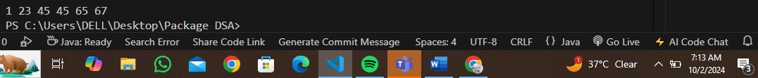

Insertion Sort: package lab6;

/* public class InsertionSort {

void sort(int arr[])

{

int n = arr.length; for (int i = 1; i < n; ++i) { int key = arr[i];

int j = i - 1;

while (j >= 0 && arr[j] > key) {

arr[j + 1] = arr[j]; j = j - 1;

}

arr[j + 1] = key;

}

}

static void printArray(int arr[])

{

int n = arr.length; for (int i = 0; i < n; ++i)

System.out.print(arr[i] + " ");

System.out.println();

}

public static void main(String args[])

{

int arr[] = { 12, 11, 13, 5, 6 };

InsertionSort ob = new InsertionSort();

ob.sort(arr);

System.out.println("sorted Arrays is :"); printArray(arr);

}

} /* */ public class InsertionSort{ void sort(int []arr){ int n =arr.length; for(int i=0;i<n;i++){ int k=arr[i]; int j=i-1; while (j>=0 && arr[j]>k)

{ arr[j+1]=arr[j];

j=j-1;

}

arr[j+1]=k;

}

}

static void printArr(int []arr){ int n=arr.length; for(int i=0;i<n;i++){

System.out.println(arr[i]+"");

}

}

public static void main(String[] args) { InsertionSort ob=new InsertionSort(); int arr[]={12,11,13,5,6}; ob.sort(arr);

System.out.println("Sorted array is"); ob.printArr(arr);

}

}

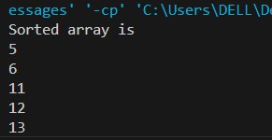

Task2: package lab6; import java.util.Arrays; public class mergeSort

{

public static void mergeSort(int[] array)

{

if(array == null)

{

return;

}

if(array.length > 1)

{

int mid = array.length / 2;

int[] left = new int[mid]; for(int i = 0; i < mid; i++)

{

left[i] = array[i];

}

int[] right = new int[array.length - mid]; for(int i = mid; i < array.length; i++)

{

right[i - mid] = array[i];

}

mergeSort(left); mergeSort(right);

int i = 0; int j = 0; int k = 0;

while(i < left.length && j < right.length)

{ if(left[i] < right[j])

{ array[k] = left[i];

i++; } else

{ array[k] = right[j]; j++;

}

k++;

}

while(i < left.length)

{

array[k] = left[i];

i++; k++;

}

while(j < right.length)

{

array[k] = right[j]; j++; k++;

}

}

}

public static void main(String[] args)

{

int arr[] = {12, 11, 13, 5, 6, 7}; int i=0;

System.out.println("Given array is");

for(i=0; i<arr.length; i++)

System.out.print(arr[i]+" "); mergeSort(arr);

System.out.println("\n");

System.out.println("Sorted array is");

for(i=0; i<arr.length; i++)

System.out.print(arr[i]+" ");

}

}

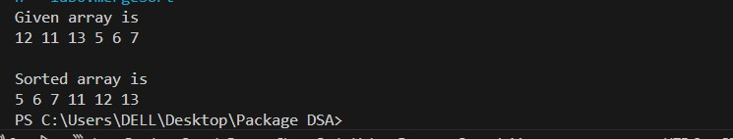

Task3:

package lab6;

import java.util.Arrays;

public class SortingFour {

public static void sortFour(int[] arr) {

if (arr.length != 4) {

System.out.println("Array must have exactly four elements.");

}

if (arr[0] > arr[1]) {

swap(arr, 0, 1);

}

if (arr[2] > arr[3]) { swap(arr, 2, 3);

}

if (arr[0] > arr[2]) { swap(arr, 0, 2); swap(arr, 1, 3);

}

if (arr[1] > arr[2]) { swap(arr, 1, 2);

}

}

private static void swap(int[] arr, int i, int j) { int temp = arr[i]; arr[i] = arr[j]; arr[j] = temp;

}

public static void main(String[] args) {

int[] arr = {3, 1, 4, 2}; sortFour(arr);

System.out.println(Arrays.toString(arr));

}

}

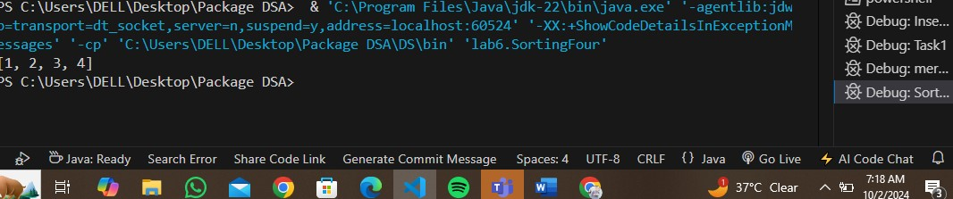

Task4:

package lab6; import java.util.Arrays; public class TwoSum { public static boolean twosum(int []arr ,int k){ Arrays.sort(arr); int left=1; int right=arr.length-1; while (left<=right) { int sum=arr[left]+arr[right]; if(sum==k){ return true;

}

else if (sum<k) {

left++;

} else{ right--;

}

}

return false;

}

public static void main(String[] args) {

int[] arr = {4, 2, 3, 4, 5,}; int k = 7;

boolean result=twosum(arr, k) ;

System.out.println(result);

}

}

